Student Volunteer Handbook

WELCOME VOLUNTEER

Dear Volunteer,
Welcome to the Students4Service volunteer program. We are delighted you are a part of our team and we look forward to offering you volunteer opportunities that will not only enrich the quality of our programs and offerings but will also give you a great volunteer experience that will allow us to utilize your skills and talents.
Regardless of your volunteer assignment, the time, dedication, and commitment you make, will allow us to improve the quality of services we will be able to offer to the Howard County Community.
The Howard County Department of Community Resources and Services’ (DCRS) staff are delighted you are coming aboard to join our team. So, on behalf of DCRS, I would like to extend a warm thank you for giving us the most generous gift one could give and that is the gift of time.
Please take a moment to read over this volunteer student manual that will provide you with valuable information regarding volunteering and will hopefully be able to answer most of your questions.
Again, please accept our sincere thanks for volunteering your time and allowing us to utilize your skills and talents to better serve the Howard County Community.
Sincerely,
DCRS S4S Committee

STUDENT VOLUNTEER HANDBOOK

Please read this manual before volunteering and continue to use it as a reference as your volunteer experience develops.

QUESTIONS:
Contact Darlene Vaselaros
410-313-5951
dvaselaros@howardcountymd.gov

Table of Contents

DCRS MISSION STATEMENT 3
S4S VISION 3
DCRS AT A GLANCE 4
DCRS GOAL 4
STUDENT VOLUNTEER HANDBOOK 5
WHAT IS S4S? 5
S4S STUDENT REQUIREMENTS 5
INTRODUCTION 6
GOALS FOR S4S PROGRAM 6
S4S VOLUNTEER BENEFTIS 6
DEFINITION OF A VOLUNTEER 7
VOLUNTEER ROLES & RESPONSIBILITIES 7
S4S AT A GLANCE 8
S4S Project Sample 8
EMERGENCY PROCEDURES 9
SEPARATION OF VOLUNTEER SERVICE 9
REPORTING VOLUNTEER HOURS 10
REPORTING VOLUNTEER HOURS – FIGURE 1 11
REPORTING VOLUNTEER HOURS – FIGURE 2 12
STAFF CONTACT INFORMATION 13

DCRS MISSION
Howard County Department of Community Resources and services

DCRS MISSION STATEMENT

The Department of Community Resources and Services supports Howard County residents and families achieve stability, independence and self-sufficiency through the provision and funding of quality human services.

S4S VISION
Building Generations Building Community

S4S VISION
To provide students with civic engaged volunteer opportunities that allow them to bring optimism and enthusiasm, create positive energy, and share diverse perspectives that lead to enhanced learning outcomes.

DCRS AT A GLANCE
As the human service arm of County government, the Department of Community Resources and Services consists of the following eight offices:
- ADA Coordination
- Aging and Independence
- Children and Families
- Community Partnerships
- Consumer Protection
- Local Children’s Board
- Human Trafficking Prevention
- Veterans and Military Families
It serves as the County’s central coordinating unit for Human Trafficking prevention, is the lead agency for the County’s Continuum of Care for homeless services; manages the Community Service Partnership program, which provides County funding to non-profit human service agencies; and administers federal, state and private source grants that support services to individuals and families in the community, including older adults, youth and homeless persons.
The Department also serves as the lead agency for mass care and shelter, and manages donations in the event of disaster. In collaboration with local private and public agencies, it plays an integral role in strengthening the effectiveness and efficiency of the County’s overall human service delivery system. Staff support is provided to the Board to Promote Self-Sufficiency, Commission on Aging and Independence, Commission on Disability Issues, Commission for Women, Consumer Affairs Advisory Board, Local Children’s Board, Early Childhood Advisory Council, Transition Council, Human Trafficking Prevention Coordinating Council and the Veterans Commission.
DCRS practices a “No Wrong Door” philosophy which allows us to quickly and efficiently link our customers to the services they need. We strive to provide services in a culturally proficient and competent manner, and consistently promote full inclusion and engagement for persons living with disabilities.

DCRS GOAL
The goal of DCRS is to ensure that every individual across the lifespan has the tools they need to live their best lives.

STUDENT VOLUNTEER HANDBOOK
Volunteering is a great way to gain personal and professional experience while making positive changes in our community. The vast array of volunteer options, provide opportunities for people of all ages to get involved and develop technical skills and educational insights not taught in the classroom. Volunteering creates lasting impacts on the health and well-being of communities and betters the lives of all involved- including the volunteer.

WHAT IS S4S?
The S4S program is designed to provide students with an exclusive volunteer opportunity to participate in an intern-like setting. This 2-week program will allow students to be exposed to having an intergenerational experience, which will give them an opportunity to learn new skills by encountering hands-on experiences through various projects throughout the DCRS Department. While the staff will provide mentorships to the students, the students involvement will offer staff a chance to take advantage of the services and diverse perspectives of the students. Students will also earn up to 32 service hours to use towards one of the requirements for high school graduation.

S4S STUDENT REQUIREMENTS
In order to be considered to participate in the S4S program, a student must:
- Be a resident of Howard County
- Be in grades 10-12th at any public or private school (entering 10th grade in the Fall)
- Enroll as a volunteer on the Howard County volunteer website at www.HoCoVolunteer.org
- Complete a work permit if under the age of 18
- Complete a Non-Disclosure Form
- Complete a Photo Waiver Release Form
- Be able to participate for the full 2-week period
IMPORTANT:
Some students will be fulfilling their assignment in other areas in Howard County, therefore please be sure you will have transportation to your designated assignment.

*Please note ALL students will be reporting to the Patuxent Woods Building (9830 Patuxent Woods Drive, Columbia) on the First and Last day of the S4S program.

INTRODUCTION
The success of the S4S program depends upon the ability of department staff and volunteers fostering and maintaining a harmonious working relationship. This is a dynamic program which will grow and evolve to meet the goals of the S4S vision, while enhancing the delivery of services performed by the DCRS Department.
This volunteer handbook is designed to answer questions pertaining to the S4S program and give guidance to the DCRS staff and student volunteers who participate. In order to give you a generalized overview of our Department, this handbook serves as a supplement to any other training or orientation you may receive from your S4S Program Supervisor related to your specific volunteer position.

GOALS FOR S4S PROGRAM
We strive to create learning environments where volunteers:
- Contribute in meaningful ways to staff success
- Reflect the diverse communities we serve
- Are valued for their unique abilities
- Are trained, mentored and supported in their work
- Are empowered to advocate for DCRS services

S4S VOLUNTEER BENEFTIS
- Human-Services Career exploration opportunities
- Intergenerational socialization outside the family structure
- An atmosphere to develop and learn new skills
- Receive training, mentoring, and support in the work that is performed
- Receive direct experience by participating in civic engaged opportunities
- Opportunities to work independently in a work-like setting
- Obtain required High School service hours

DEFINITION OF A VOLUNTEER
A “volunteer” is anyone who, without compensation or expectation of compensation beyond reimbursement, performs a task at the direction of and on behalf of DCRS. A “volunteer” must be officially accepted and enrolled by the S4S program prior to performance of any tasks.

VOLUNTEER ROLES & RESPONSIBILITIES
Volunteers have specific responsibilities not only to the volunteer station where they work, but to the entire DCRS Department, who which you are representing. Therefore, you must be prepared to fulfill your volunteer commitments and responsibilities.

- You must be open and honest regarding intent, goals and skills.
- You must accept only realistic assignments and have a clear understanding of your job/assignment.
- You must be sincere in the offer of service and believe in the value of the job to be done.
- You must carry out duties promptly and reliably.
- You must be willing to learn, and accept guidance and direction from staff.
- You must communicate any problems and concerns so that they may be discussed and resolved. Be sure to ask questions about things you don’t understand.
- You must be punctual, and notify your support S4S Program Supervisor of absences as much in advance as possible. (See page 13 for staff phone numbers)
- You must maintain the dignity and integrity of the community service with the public.
- You must record your daily/weekly volunteer hours on our volunteer website, www.HoCoVolunteer.org (See page 10 for instructions)
- If interested in receiving service hours, you must bring the appropriate paperwork for the Site Supervisor to sign on the Thursday before the last day of the program.

S4S AT A GLANCE
Each S4S Program Supervisor has been asked to provide the S4S Committee with a project plan, describing the project they will need the student(s) to accomplishment within the 2-week period. Below is a sample plan to give you an idea of a project.

S4S Project Sample
Infographic for Office on Aging and Independence
This project centers around building a newsletter for a DCRS program. It is designed around a 10-day work week that includes two telework das (8 days total in the office).

Day | Task
Day 1 (Monday) | S4S Intro / Orientation
Day 2 (Tuesday) | Work on the format/outline of the infographic
Day 3 (Wednesday) | Interview staff members to identify key information to present on an infographic; keeping in mind the audience for the infographic is the consumer.
Day 4 (Thursday) | Continue to interview program managers, center directors/asst. directors, and division managers.
Day 5 (Friday) | Telework Day
Day 6 (Monday) | Do online research about older adults and best practices around the country and incorporate new information.
Day 7 (Tuesday) | Consolidate information and work on infographic.
Day 8 (Wednesday) | Telework Day
Day 9 (Thursday) | Present draft infographic and revise as needed.
Day 10 (Friday) | Closing Ceremony – Present infographic

EMERGENCY PROCEDURES
- In an emergency: Dial 911 (from 313 extensions, dial 9+911)
- Without delay, contact your immediate supervisor
- If you are unable to reach your immediate supervisor, contact the following people in the order listed until you reach someone:
  - Tomiko Thomas, Housing/Assistant Living Coordinator 410-313-6542
  - Kori Jones, OLCB 410-313-0039
  - Darlene Vaselaros, Volunteer Coordinator 410-313-5951
  - Courtney Barkley, Health & Wellness Division Manager 410-313-5957
  - Kaya Swann, PFC Program Manager 410-313-1453
- Poison Control: 410-528-7701
  - Identify the poison, if possible

SEPARATION OF VOLUNTEER SERVICE
As volunteers willingly and freely offer services with no expectation of payment or compensation, DCRS recognizes the right of volunteers to discontinue their service at any time for any reason.

Volunteers serve at the pleasure of the Appointing Authority of the Department/Agency (or their designee) and may be dismissed from volunteer duties at any time, with or without cause. A volunteer may not be selected for volunteer service. This determination may be made with or without cause.

Volunteers are expected to act as positive role models and exhibit strong leadership skills. When the department observes or receives a complaint about inappropriate behavior on the part of a volunteer, the incident or alleged incident will be promptly addressed or investigated. If it is determined that the complaint is valid, and warrants discipline, the following progressive actions may occur:
- First incident: verbal counseling with department staff. (Note: the severity of the incident may warrant more severe action at the first incident).
- Second Incident: written warning with a one (1) week suspension.
- Third Incident: the volunteer will be suspended from current volunteer position and will not be able to volunteer again for one (1) year. The suspension shall run from the date of the suspension until that date the following year.
- Any additional incidents will result in an indefinite suspension from all department sponsored programs, events and activities.

If a volunteer is not satisfactorily completing their duties, the coordinator/program supervisor
will meet with the volunteer or contact the volunteer by phone to apprise them of the situation. If necessary, a dismissal letter will follow.

REPORTING VOLUNTEER HOURS
- To log volunteer hours, sign-in on the website (www.HoCoVolunteer.org) using your username and password
- Click Report & View Hours (Figure 1)
- Click Report Service (Figure 2)
  - *If you are signed up for more than the S4S program volunteer opportunity on our website, then please be sure to select the S4S survey on the scroll down menu below the Report Service button
- For the Start Date, enter the first day of the S4S program and use the same date for the End Date (Figure 2)
- Enter the total amount of hours you served for that day next to “How many hours did you serve?” (Figure 2)
- Click Ok (Figure 2)

* OR you can just enter the first day of the S4S program as the Start Date and the last day of the S4S program as the end date and put the TOTAL amount of hours you served for the entire 2 weeks.

REPORTING VOLUNTEER HOURS – FIGURE 1

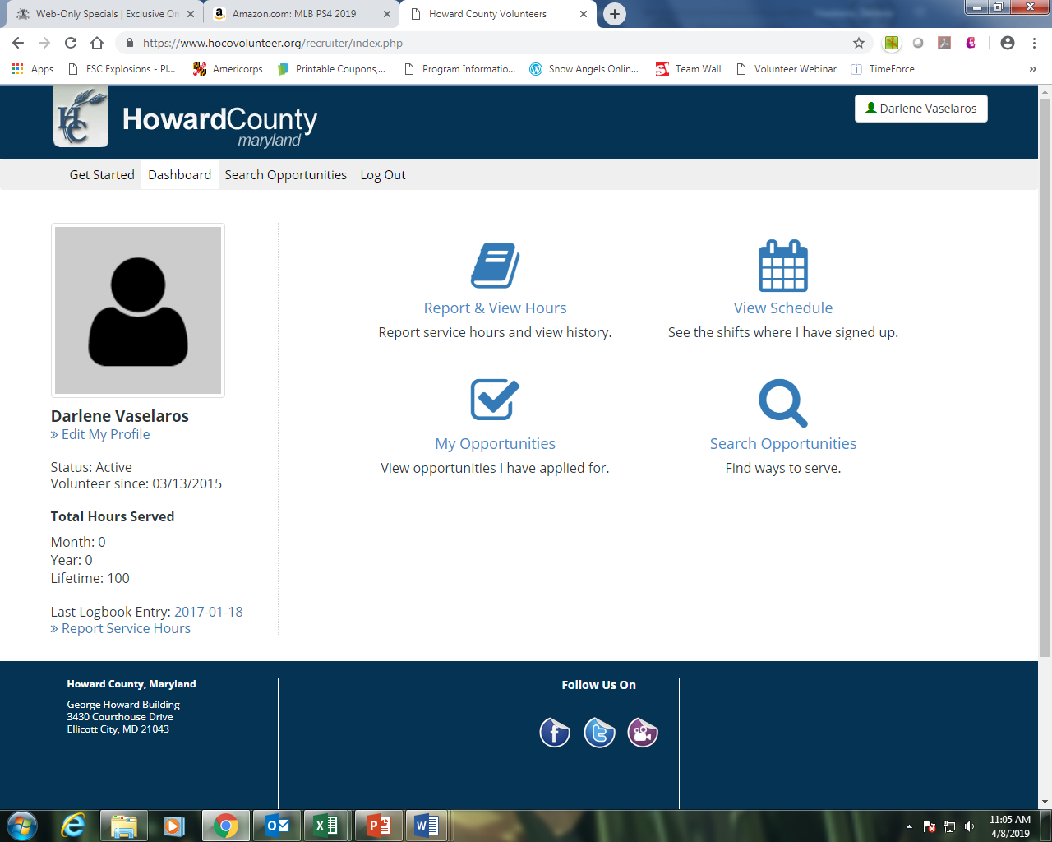

Reporting
Volunteer
Hours
Figure 1

REPORTING VOLUNTEER HOURS – FIGURE 2

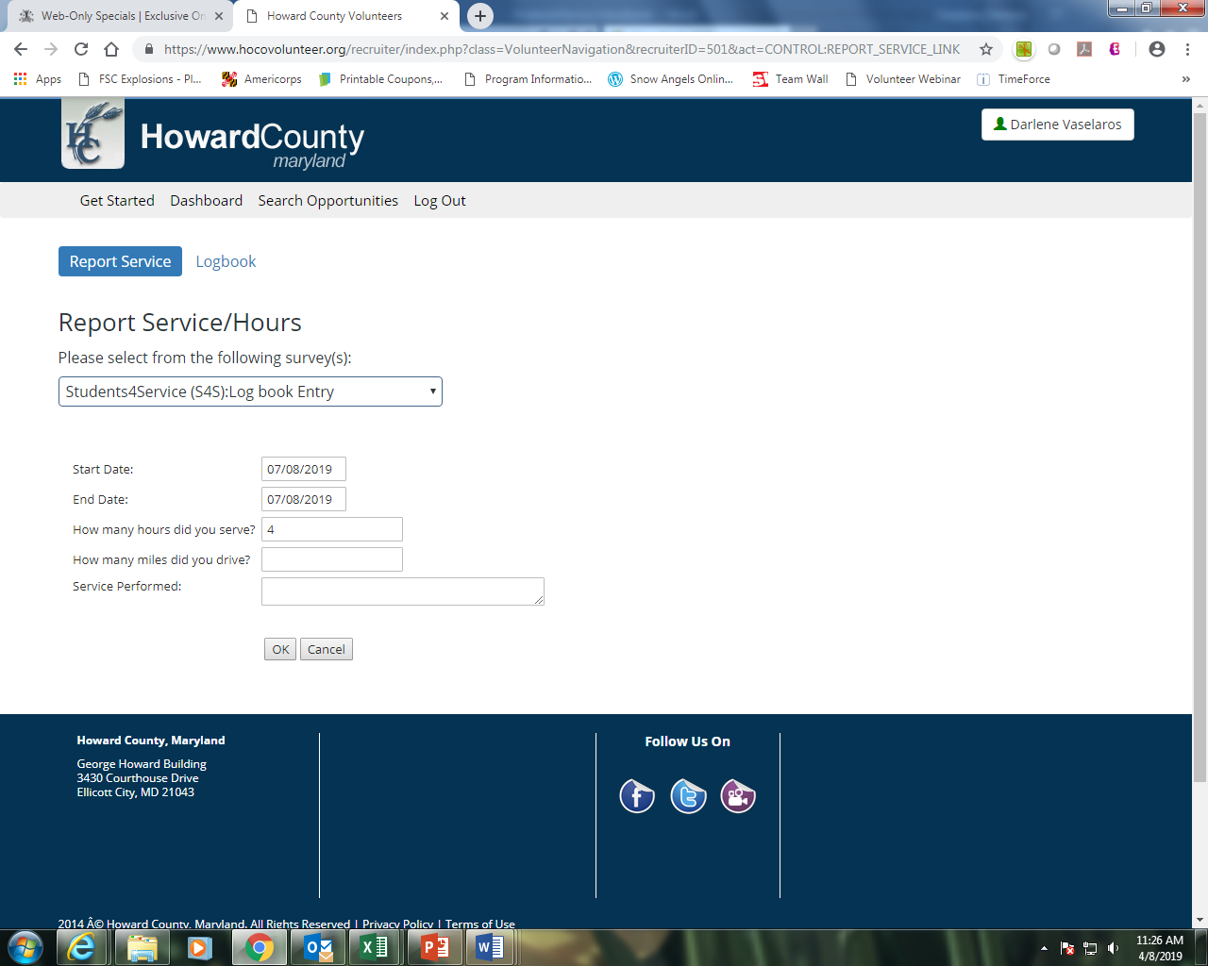
Figure 2

STAFF CONTACT INFORMATION

S4S Committee
Courtney Barkley | 410-313-5957
Kaya Swann | 410-313-1453
Tomiko Thomas | 410-313-6542
Darlene Vaselaros | 410-313-5951

S4S Program Supervisor |  | Division
Malarie Burgess | 410-313-6073 | Health & Wellness
Jeanna Crawley | 410-313-6422 | OAI Administrator
Vanessa Hughes | 410-313-6026 | Senior Care
Regina Jenkins | 410-313-5443 | Glenwood 50+ Center
Chris Moore | 410-313-6029 | Maryland Access Point
Trisha Olsen | 410-313-0389 | North Laurel 50+ Center
Lisa Rhodes | 410-313-1440 | Family Institute/OCF
Kaya Swann | 410-313-1453 | OCF/PAT Program
Earnestine Thomas | 410-313-5969 | Caregiver Support Program
Tomiko Thomas | 410-313-6542 | Housing/Assisted Living
Darlene Vaselaros | 410-313-5951 | Volunteer Program
Joan Weimer | 410-313-6489 | OAI Supports Planning

